The Greedy Zombie Game

1. Introduction.

The idea behind this week class was to interview and be interviewed by different clients in regards the development of a game.

Different scenarios have been distributed to each team to follow.

The reason for doing this was to simulate a real-world scenario that would make the students understand what questions to ask clients and the developers to create a project to pitch back to the client.

If the client liked the idea then the project would be marked as successful and get founded.

The clients were Jessica Evans, Callum Weaver and Samiul Bari

Client Brief.

* 18+ game
* Two week deadline
* £2000 budget
* Extremely profitable
* Most successful game in the world
* The client had no technical experience

1. Requirements for playing the game.

* Phone with a good camera
* Game application
* No animal violence
* Lots of adds within the game

1. Project and rules.

The game itself would be created on an augmented reality. Since it would not be any graphical development in the game and that

* Augmented reality game that allowed you to see zombies using your phone.
* The user will use a phone to look around the environment that they are in to find zombies.
* Killing zombies will award the player with points.
* Killing a zombie by headshot will award the player 15 points. A standard kill awards them 5 points.
* The player can use the points to purchase ammo.
* Endless amount of zombies will spawn

1. Gameplay.
2. Player uses the phone camera to search the environment to see if there is any danger.
3. At night zombies move at a faster speed
4. Bullets can be purchased on the map at different points.
5. Player has to either to run if no bullets or kill the zombies.

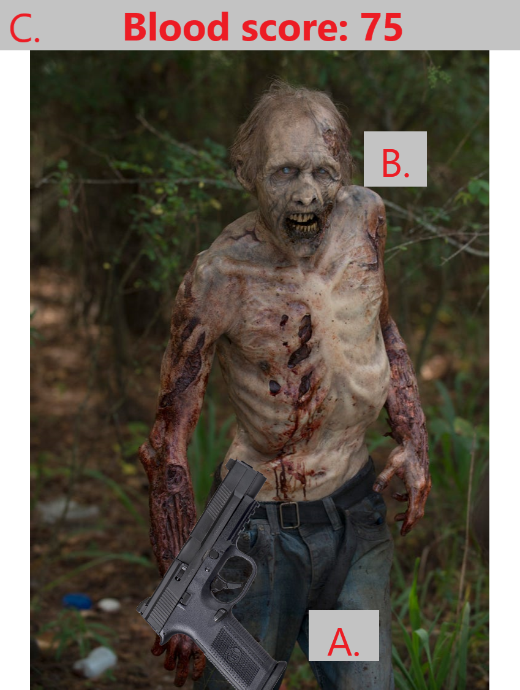

Figure 1. Showing user interface through a mobile camera. [A] was the weapon the player has equipped, [B] is the augmented zombie and [C] is the score and currency the player has at the moment.

1. Future improvement.

Since the game would start as a prototype because of the 2k founding, the improvement list was quite great and even more ideas can be added to the list.

* Ads when purchasing weapons, entering hotspots/events, if player died and need reviving.
* Use Google maps to find different zombie hotspots - graveyards.
* More weapons - flamethrowers, grenades, rocket launchers.
* Different types of zombies/opponents.
* Game events at real world events such as blood moon.
* Zombie hordes from graveyards.
* Give higher rewards at hotspots.
* Different options.
* Even more Ads to make more money.

The overall session was very active and rewarding as it provided information on what would be required of developers in a real world experience and it is something to think about and get a certain set of rules that can help developers understand any client needs.

The good work of the team has been rewarded with the acceptance of the client who accepted the proposal and helped start the development.

The team that developed the games was made up by Alexandru Zarnescu, Jack Collins and Jamie Smith.